Experiment 9
Packet Capture & Protocol Analysis

Lab 9 Objectives:
● Capture packets and study protocol behavior for web browsing, file transfer, and domain resolution.
Prerequisites: The prerequisites of this lab are-
● Basic understanding of networking protocols (HTTP, FTP, DNS, etc.).
● Familiarity with packet analysis tools.

Outcomes: By the end of this lab, students will be able to:
● Capture and analyze network traffic for different services.
● Identify protocol-specific behaviors and data exchange patterns.
● Understand request-response mechanisms in web and file transfer protocols.

1. Use a packet capture tool to monitor network traffic
In this step, we use a packet capturing tool such as Wireshark or tcpdump to monitor all the traffic passing through a network interface. These tools capture packets in real time and display important details such as:
- Source and destination IP addresses
- Protocol used (e.g., HTTP, DNS, FTP)
- Port numbers
- Packet length
- Summary of the packet content

This process is crucial for analyzing how different network protocols behave during communication. Using a capture tool, we can observe each step of data exchange and detect problems like latency, retransmission, or packet drops.

Tools Used:
- Wireshark (Graphical interface – ideal for students)
- tcpdump (Command-line based – optional)
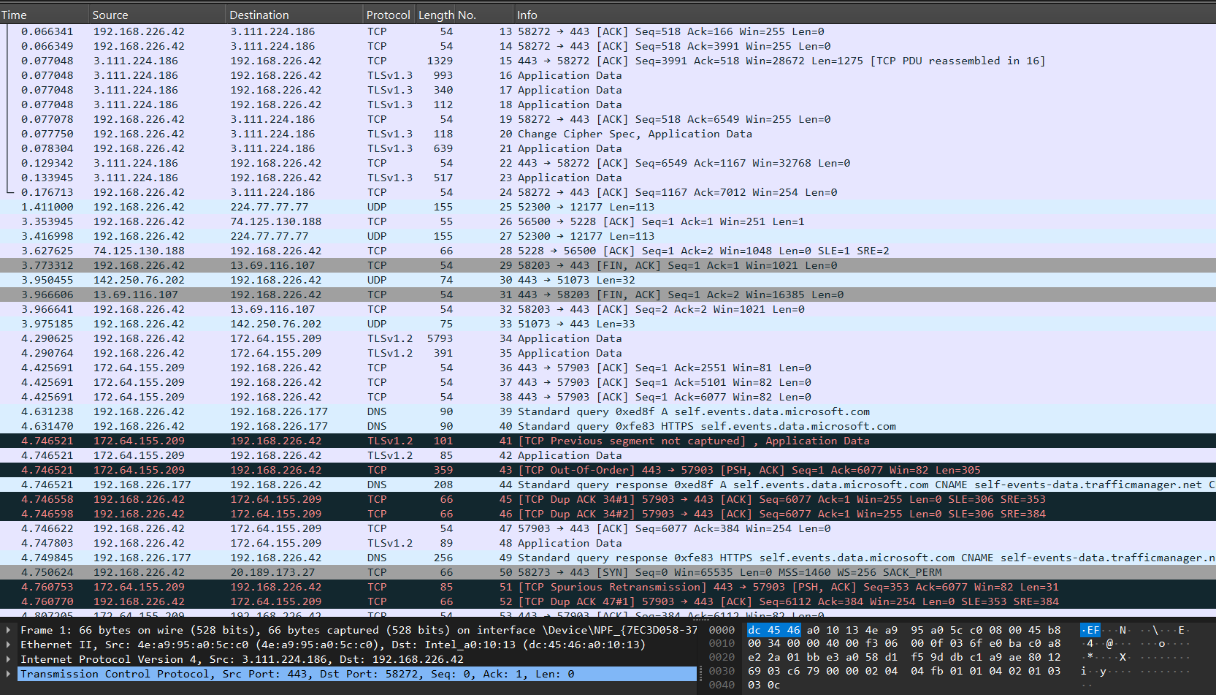

These tools capture packets in real time and display important details…

2. Perform web browsing and analyze HTTP/HTTPS packet exchanges
This step involves visiting websites using a web browser (such as Chrome or Firefox) and observing how HTTP and HTTPS protocols behave during data exchange.
- HTTP (Port 80) is a plain-text protocol. In Wireshark, we can see the full request and response, including headers, method (GET/POST), and HTML content.
- HTTPS (Port 443) is encrypted using TLS (Transport Layer Security). Although we cannot see the data content, we can observe the TLS handshake, encryption details, and connection setup.

What to Observe:
- HTTP packets show readable content (but are insecure).
- HTTPS packets are encrypted (secure but content is hidden).
- TLS handshake process (Client Hello, Server Hello, Certificate, etc.)
This step helps us understand the difference between secure and non-secure communication on the web.

Filter: http
Show request and response headers

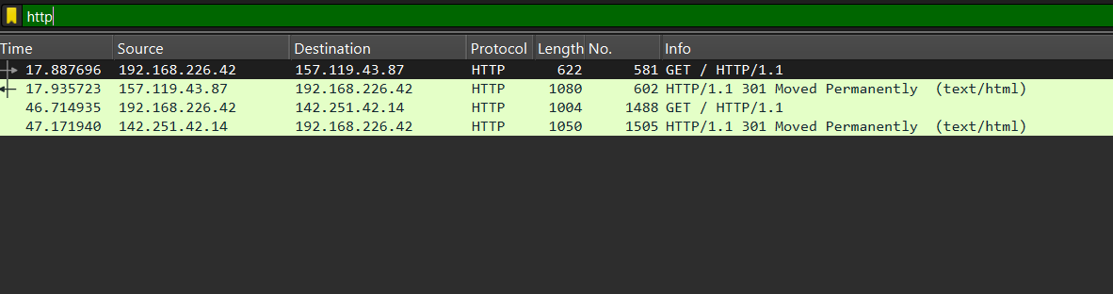

Filter: tls or ssl
Show TLS handshake: “Client Hello”, “Server Hello”, “Certificate”

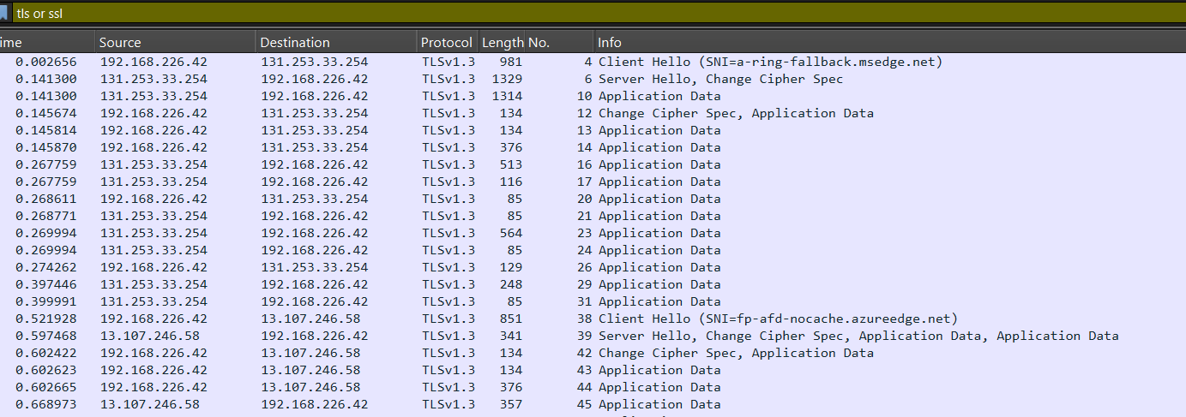

3. Initiate a file transfer using FTP or SCP and observe protocol behavior
In this step, we initiate a file transfer using either:
- FTP (File Transfer Protocol) — Port 21
- SCP (Secure Copy Protocol) — Port 22 (via SSH)

We use an FTP client to connect to a server, login, and transfer a file.
In Wireshark, we can observe:
- USER and PASS commands (FTP login)
- RETR, STOR, or LIST commands
- Actual file transfer data

On the other hand, SCP is secure and encrypted using SSH. The packets transferred in SCP cannot be read, but we can still observe the connection initiation and encryption handshake.

Key Differences:

- FTP is insecure — credentials and file content are visible.
- SCP is secure — data is encrypted and unreadable.

4. Resolve a domain name using DNS lookup and inspect DNS queries and responses

This step involves resolving a website’s domain name (e.g., google.com) into an IP address using tools like nslookup, dig, or by simply browsing the website.
- DNS (Domain Name System) works mostly over UDP on port 53.
- A DNS Query is sent to the DNS server asking for an IP address.
- The DNS Response contains the answer (typically an A-record).

In Wireshark, DNS packets are easy to recognize. You can analyze:
- Query type (A, AAAA, MX)
- Response time
- IP addresses returned

Observation:
- DNS is fast but not reliable (uses UDP, no error correction).
- If DNS over HTTPS (DoH) is used, content is encrypted.

5. Compare protocol behaviors in terms of latency, security, and reliability
In this step, we compare all the protocols studied based on three important parameters:
Protocol | Latency | Security | Reliability
HTTP | Low | Not secure (plain) | Reliable (TCP)
HTTPS | Medium | Secure (TLS/SSL) | Reliable (TCP)
FTP | Medium | Not secure (plain text) | Reliable (TCP)
SCP | Medium | Fully secure (SSH) | Reliable (TCP)
DNS | Very Low | Not secure (unless DoH) | Unreliable (UDP)

Explanation:
- Latency: DNS and HTTP are faster, HTTPS and FTP are slower due to encryption and handshakes.
- Security: HTTPS and SCP are secure; HTTP, FTP, and plain DNS are not.
- Reliability: TCP-based protocols (HTTP, HTTPS, FTP, SCP) are reliable; DNS (UDP) is faster but less reliable.

6. Document captured packet details, protocol behavior, and observations
In the final step, we create a summary of all captured packets and document our observations.
For each protocol, include:
- Captured screenshots (from Wireshark)
- Source and destination IPs
- Port numbers and protocol
- Request and response details
- Timestamps and packet size
- Behavior and pattern observed

What to write in observations:
- HTTP data was fully visible including page content.
- HTTPS used TLS encryption; data was not visible.
- FTP credentials and file names were clearly readable.
- SCP was completely encrypted and secure.
- DNS responses showed IP addresses for domain names.

Perform web browsing and analyze HTTP/HTTPS packet exchanges
Screenshot : HTTP traffic (open http://google.com)
- Filter: http
- Show request and response headers
- Highlight method: GET and HTML content in the packet

📷 Screenshot #3: HTTPS traffic (open https://google.com)
- Filter: tls or ssl
- Show TLS handshake: “Client Hello”, “Server Hello”, “Certificate”

